Report Template for the Data Science Course∗
  - Project Title (replace with real title)
  - Primary Topic: XXX, Secondary Topic: XXX
  - Course: 2018-1A – Group: XXX – Submission Date: 2018-XX-XX

Sara Tabby Udent†
University of Twente
email@email.com
Simon Tudent
University of Twente
email@email.com

ABSTRACT
This paper provides a sample of a Word document for the reports in the Data Science Course. It is based on the ACM Conference Template.
KEYWORDS
some keywords shortly describing your paper
1 INTRODUCTION
This template should be used for reports in the Data Science course.
Its intention is to provide help with preparing a professional, concise report, that nevertheless contains all necessary information about the project.
2 GUIDELINES
Reports for the Data Science course should adhere to the following guidelines.
- page limit is 5 pages (references and appendix do not count towards the page limit)
- fonts, font sizes and margins in the template should not be changed
- all meta-data should be provided in the report (project title, primary and secondary topic, course number, group number, submission date)
3 STRUCTURE
The paper should be structured into sections and subsections. Inside sections and subsections, paragraphs can be used to indicate a new line of thought.
The following subsections detail how citations, equations, tables and figures are included.
3.1 Citations
You can use a reference manager (e.g. Endnote) or include citations manually By the way, J.L. Lebrun's book is a nice introduction to scientific writing [1].
3.2 Math Equations
For displaying a formula with number, us the Display Formula Style as follows:
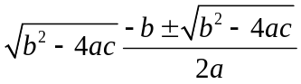 (1)
After the formula the style for the text must be set to ParaContinue, For a formula without a number use the Display Formula without Number style, which produces the following result:
3.3 Tables
Captions for tables should be above the table. Tables can be references as well, see Table 1.
Table 1. Caption goes above table
Col 1 | Col 2 | Col 3
Nothing really in here | Here also not
3.4 Figures
Figures have their caption below and can be referenced. See Figure 1.
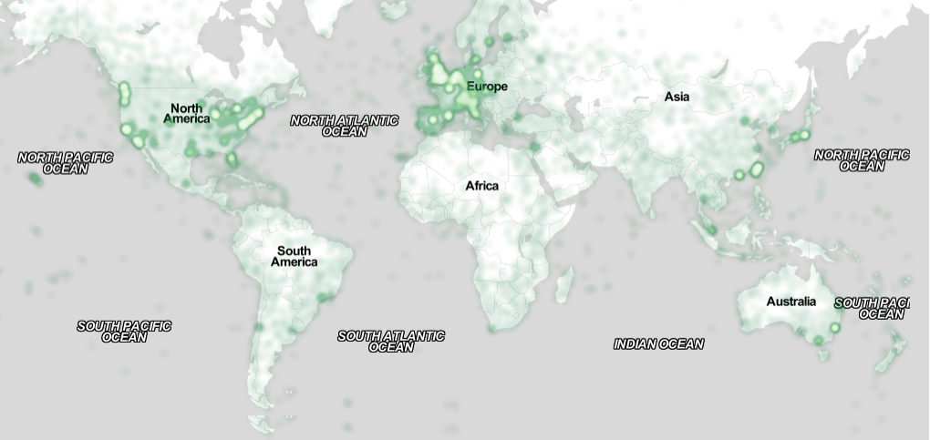
Figure 1 A figure with a caption
4 CONCLUSION
Some dummy texts to fill some space.
4.1 Dutch
Ik ben makelaar in koffi, en woon op de Lauriergracht No 37. Het is mijn gewoonte niet, romans te schrijven, of zulke dingen, en het heeft dan ook lang geduurd, voor ik er toe overging een paar riem papier extra te bestellen, en het werk aan te vangen, dat gij, lieve lezer, zoâven in de hand hebt genomen, en dat ge lezen moet als ge makelaar in koffie zijt, of als ge wat anders zijt. Niet alleen dat ik nooit iets schreef wat naar een roman geleek, maar ik houd er zelfs niet van, iets dergelijks te lezen, omdat ik een man van zaken ben.
Sedert jaren vraag ik mij af, waartoe zulke dingen dienen, en ik sta verbaasd over de onbeschaamdheid, waarmee een dichter of romanverteller u iets op de mouw durft spelden, dat nooit gebeurd is, en meestal niet gebeuren kan.Als ik in mijn vak -- ik ben makelaar in koffie, en woon op de Lauriergracht No 37 -- aan een principaal -- een principaal is iemand die koffie verkoopt -- een opgave deed, waarin maar een klein gedeelte der onwaarheden voorkwam, die in gedichten en romans de hoofdzaak uitmaken, zou hij terstond Busselinck & Waterman nemen.
Dat zijn ook makelaars in koffie, doch hun adres behoeft ge niet te weten. Ik pas er dus wel op, dat ik geen romans schrijf, of andere valse opgaven doe. Ik heb dan ook altijd opgemerkt dat mensen die zich met zoiets inlaten, gewoonlijk slecht wegkomen. Ik ben drieënveertig jaar oud, bezoek sedert twintig jaren de beurs, en kan dus voor de dag treden, als men iemand roept die ondervinding heeft. Ik heb al wat huizen zien vallen! En gewoonlijk, wanneer ik de oorzaken naging, kwam het me voor, dat die moesten gezocht worden in de verkeerde richting die aan de meesten gegeven was in hun jeugd.
4.2 Latin
Lorem ipsum dolor sit amet, consectetur adipiscing elit. Nullam nec mi in neque rhoncus imperdiet et vel metus. Class aptent taciti sociosqu ad litora torquent per conubia nostra, per inceptos himenaeos. Morbi auctor vitae purus sit amet viverra. Nam facilisis urna id magna porttitor lobortis sed nec diam. Nullam sit amet laoreet lectus. Suspendisse convallis nulla ut finibus gravida. Nulla ut tortor eu tortor scelerisque accumsan non id leo. Interdum et malesuada fames ac ante ipsum primis in faucibus. Proin interdum, odio sit amet bibendum pretium, tortor ante aliquet libero, eget facilisis ligula diam finibus quam. Aenean auctor ornare neque, vel imperdiet lacus consequat ac. Mauris sed arcu nec sapien venenatis ullamcorper.
Duis elementum risus at eros vestibulum fringilla. Sed id felis quis arcu dignissim tincidunt et placerat est. Sed in finibus neque, a tristique felis. Aenean mollis ligula sed neque iaculis, id dignissim lorem vestibulum. Curabitur et purus at nulla eleifend facilisis in quis sem. Vivamus et justo vel risus dignissim maximus. Maecenas dapibus viverra felis eget interdum. Praesent venenatis sapien eu lectus porta fermentum. Aliquam nunc enim, sagittis id justo a, pellentesque sollicitudin magna. Etiam eget lacus dolor. Maecenas eget nisi ex. Nunc in pulvinar elit. Aenean efficitur velit nec egestas tincidunt.
Donec nec est egestas, pulvinar nibh et, sagittis arcu. Nullam in egestas elit. Praesent feugiat, lorem ac varius pharetra, nisl est efficitur odio, a elementum neque nibh nec lacus. Sed ac mauris ac massa vestibulum convallis in ac urna. Duis sed auctor eros, vel sodales est. Ut vulputate fermentum libero. Maecenas consectetur at dolor eu condimentum. Nam fringilla aliquam ipsum id scelerisque. Aenean vitae interdum urna. Aenean egestas ex sed euismod laoreet. Nulla sit amet velit felis. Maecenas a libero a dui mollis congue ut ac magna. Proin quis dictum velit. Praesent dapibus orci at nisi viverra hendrerit. Nam imperdiet blandit libero tempus bibendum.
4.3 Kafka
One morning, when Gregor Samsa woke from troubled dreams, he found himself transformed in his bed into a horrible vermin. He lay on his armour-like back, and if he lifted his head a little he could see his brown belly, slightly domed and divided by arches into stiff sections. The bedding was hardly able to cover it and seemed ready to slide off any moment.
His many legs, pitifully thin compared with the size of the rest of him, waved about helplessly as he looked. "What's happened to me? " he thought. It wasn't a dream. His room, a proper human room although a little too small, lay peacefully between its four familiar walls. A collection of textile samples lay spread out on the table - Samsa was a travelling salesman - and above it there hung a picture that he had recently cut out of an illustrated magazine and housed in a nice, gilded frame. It showed a lady fitted out with a fur hat and fur boa who sat upright, raising a heavy fur muff that covered the whole of her lower arm towards the viewer. Gregor then turned to look out the window at the dull weather.
A SECTION IN THE APPENDIX
Appendices can be used for additional material that do not fit into the main body in the paper but are still important. The main part should be understandable without the content in the appendices. Candidates for such content are lists of parameter settings, additional results (that show the same already shown before but on different data) or additional example images.
ACKNOWLEDGMENTS
If you use special data sets or got some other help, here is the right place to mention it. Otherwise, this section can be left out.
REFERENCES
[1] Simon Fear. 2005. Publication quality tables in LATEX. http: //www.ctan.org/pkg/booktabs.
[2] Jean-Luc Lebrun. 2011. Scientific Writing 2.0. WORLD SCIENTIFIC. https://doi.org/10.1142/8156 arXiv: https://www.worldscientific.com/doi/pdf/10.1142/8156

